**Assignment: Day 3**

**#Task 2**

**Question:** Learn the concepts of Branching and Merging and create a doc on it. Push the same doc on Git as a separate file named it as day3_task.txt.

**Branching:** The branching in git is done with the help of the ***git branch*** command. This command can list the branches you have, create a new branch, delete branches and rename branches. For creating a new branch we use the command ***git branch “Branch Name”.***

If we want to set up a tracking branch we use ***git branch -u.***

If we want to switch branches and check content out into the working directory we use ***git checkout*** command.

**Merging:** The ***git merge*** tool is used to merge one or more branches into the branch you have checked out. This command will then advance the current branch to the result of the merge. This command was first used in basic branching.

We use ***git merge <branch>*** with the name of the single branch we want to merge in.

**#Task 3**

**Question:** What is an Elastic IP and how it is different from Dynamic IP?

Ans: Elastic IP addresses are used by the AWS for managing dynamic cloud computing services. It is also known as static IPv4 addresses. The elastic IP address is what is used to advertise the data within the instance to the public internet.

It is different from dynamic IP because the IP address in dynamic IP changes from time to time whereas in elastic IP this won’t happen.

**Question:** What is the Client-Server Model, Explain in detail?

Ans: The client-server model is a distributed application structure that usually partitioned tasks between the providers of a service (servers) and service requesters (clients).

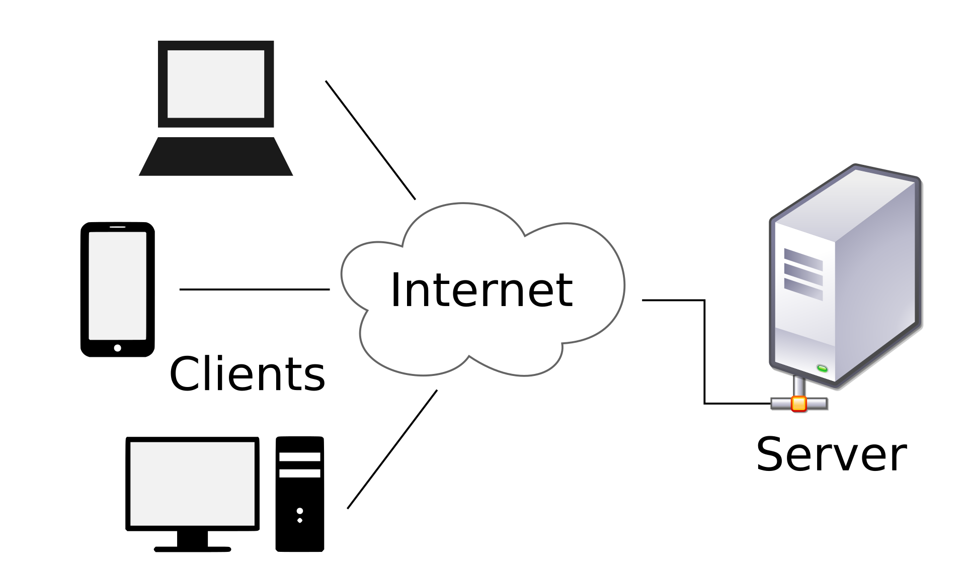

Most of the time client and server communicate through a computer network on separate hardware, but often client and server may reside in the same system. In this, the server host runs one or more programs and they share these programs with clients. In this, the clients do not share their resources and they request survive from the servers. Clients initiate the communication session with servers due to which the incoming requests are awaits. Some of the examples of client server model are email, world wide web etc.